English  Please ensure your child is continuing with phonics and reading. | Writing:  Write a diary entry from a day in the life of ‘Incy Wincy Spider’ and practice learning Nursery Rhymes at home.  Reading:  Read your book once a day and use the teach monsters to read programme. Class teacher can check your progress via the internet. | Phonics:  Go on to phonics play.  Login: march20 password home.  Use the phase 3/5 trucks to practice High frequency words.  Play the games from phase 3/5. | Go onto your purple mash login, access the games: Sam and Pat play ball, Sentence sequencing, Suffixes and the wolf and Jim takes out the rubbish.  These have been set as ‘2do’s’ and should be found under the purple symbol.  Teacher can check and mark your progress.
Maths | Multiplication and division  Practise counting in twos, fives and tens  Say a multiple of two, five or ten and ask your child to tell you the previous or next multiple  Record multiples for twos, fives and tens  Record repeated addition number sentences  E.g. 2+2+2= 5+5+5+5 =  Websites:  http://www.topmarks.co.uk/maths-games/5-7-years/multiplication-and-division  http://www.bbc.co.uk/bitesize/ks1/maths/multiplication/play/  https://www.everyschool.co.uk/maths-key-stage-1-multiplication.html | Fractions  Work out halves and quarters of everyday things such as pizza and fruit  • Draw and cut out shapes to half and quarter  • Work out halves and quarters of numbers E.g. What is half of 8? What is a quarter of 8?  • Investigate if all numbers can be halved Websites:  http://www.bbc.co.uk/guides/zq2yfrd | Number Bonds Practise Number bonds to numbers 1-20  • One more and one less for numbers to 100 Websites:  http://www.topmarks.co.uk/Search.aspx?q=number%20bonds%20to%2020  http://www.ictgames.com/moreless.htm  http://www.topmarks.co.uk/Search.aspx?q=ONE%20MORE%20OR%20LESS  Maths will also be set as to do alerts in purple mash
Topic | To make a bug hotel together in the garden, draw a picture of what you have made.  Write a set of instructions on how to make a bug house. | Read your book for 10 minutes a day, challenge yourself to read a variety of books. | Go on a nature walk with your family, can you see any mini beasts in their natural habitats. When you get home draw pictures of what you have seen. What other local animals did you see?  Can you create a diagram sorting animals into farm animals and not or wild animals or nor
Working Together | Create a poster of the animals that can be found within our local area. Go on a family walk and see how many animals you can spot in your local environment. | Using a shoe box create your animal habitat  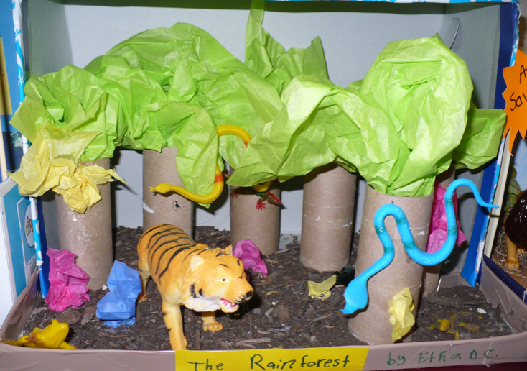. | Create pictures of your favourite bug or animal and research facts all about them.  Grow plants with your family. Explore facts about plant growing and why it is important.

