You can select any activities from the list below or come up with your own ideas to suggest to your teacher.
Please record any home learning on Tapestry and, feel free to email in any photos or relevant learning, we really love seeing your pictures and what the children have been doing!

Easter
English | Phonics  Listen to the phonics song – can you find the first letter of your name? Can you find ‘m’ for Mummy or ‘d’ for Daddy?  https://www.youtube.com/watch?v=saF3-f0XWAY | Reading  Share the Easter story with your family.  https://www.topmarks.co.uk/easter/easterstory.aspx  https://www.bbc.co.uk/cbeebies/stories/lets-celebrate-easterperformance | Writing  Can you write your name and decorate it with Easter symbols like a cross, a lamb, an Easter egg?
Maths | Number  Can you go on an egg hunt around the garden? How many eggs can you find? Can you find that number or write the number? | Measure  Can you make an Easter treat to share with your family? How much of each ingredient do we need? Which is the heaviest/ lightest ingredient? | Shape  Can you make an Easter egg picture? What shapes can you decorate it with?
Topic | Creative  Can you use junk modelling to create an Easter basket to keep all your Easter treats in? | Understanding of the World  Watch the videos about how Toby celebrates Easter. Do you do any of these things with your family?  https://www.bbc.co.uk/cbeebies/watch/lets-celebrate-easter | Creative  Can you make a cross? You could use sticks and twigs or decorate a picture of a cross?  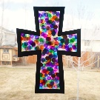
Easter Craft ideas
Chick hand print Toilet roll print rabbits Easter egg sun catchers
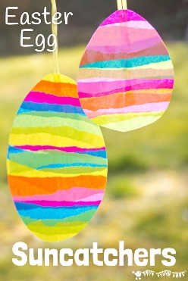
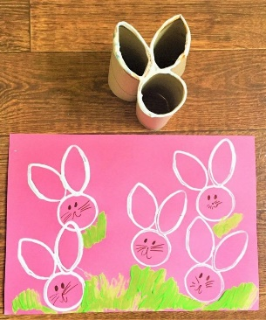
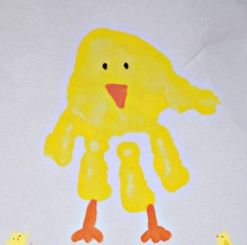

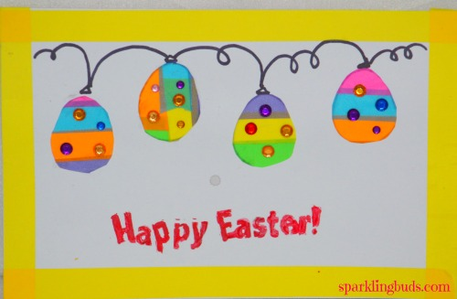
Make an Easter card for family you can’t see.
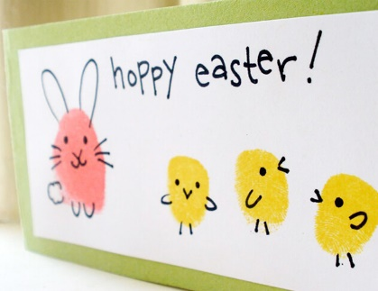

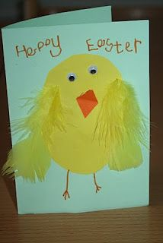

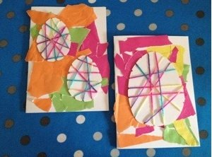

Websites
https://www.topmarks.co.uk/maths-games/3-5-years/counting This is a brilliant website for lots of Maths games
https://www.bbc.co.uk/cbeebies/games
https://www.getepic.com/?fbclid=IwAR1it4kzUNFsnAFl4OVf3c9nokeSYe7pA4lr1mg7nVlNV58LRredL3nzbiA This link is for a free 30 day trial for 1000s of online books
https://www.youtube.com/user/oxbridgebaby Lots of lovely traditional tales to watch and listen
https://theimaginationtree.com/best-ever-no-cook-play-dough-recipe/
https://www.teachyourmonstertoread.com/ A free app with lots of reading activities
https://fiveminutemum.com/ a website with lots of easy to set up activities for Maths, writing and social skills.

Outdoor Learning
- Bug hunt, what insects can you find? Can you research a fact about them? Can you draw a picture of the bugs?
- Den building
- Spring hunt – What signs of Spring can you find in the garden?
- Can you make a bug hotel using natural resources?
- Can you make a pretend bonfire and sing songs/ share a story around the fire?
- Can you make patterns rubbing different leaves?
- Can you make a mud kitchen using old kitchen utensils? What can you make in it?

