You can select any activities from the list below or come up with your own ideas to suggest to your teacher.
Please record any home learning on Tapestry and, feel free to email in any photos or relevant learning.
English | Phonics  Can you go on an initial sound hunt?  We have learnt s, a, t, p, i, n, g, o  What can you find around the house that start with these sounds? | Reading  Enjoy a story, either share a book or watch an online story.  https://www.bbc.co.uk/cbeebies/stories | Writing  Can you practise writing your name?
Maths | Number  Can you go on a number hunt at home? Where can you find lots of numbers? | Measure  Who is the tallest person in your family? Who is the shortest? | Shape  Can you make a picture using lots of different shapes? Can you name the shapes?
Topic | PSED/ C&L  Can you play a board game? Are you able to take turns with your friends? | Understanding of the World  Can you make a chocolate Easter nest? What happens when you put the chocolate in the microwave? | Creative  Can you design an Easter egg? Can you decorate a hard boiled egg?
Topic | Animals  Can you draw around shapes to create an animal? Can you colour it in staying in the lines? | The Gruffalo  Share the story of the Gruffalo. What characters are in the story? Who is your favourite?  Draw a picture of your favourite character and where it lives. | Playdough  Can you make some playdough? What colour have you made?  Can you make patterns in the dough?  Can you make shapes with the dough?

Websites
https://www.topmarks.co.uk/maths-games/3-5-years/counting This is a brilliant website for lots of Maths games
https://www.bbc.co.uk/cbeebies/games
https://www.getepic.com/?fbclid=IwAR1it4kzUNFsnAFl4OVf3c9nokeSYe7pA4lr1mg7nVlNV58LRredL3nzbiA This link is for a free 30 day trial for 1000s of online books
https://www.youtube.com/user/oxbridgebaby Lots of lovely traditional tales to watch and listen
https://theimaginationtree.com/best-ever-no-cook-play-dough-recipe/
https://www.teachyourmonstertoread.com/ A free app with lots of reading activities
https://fiveminutemum.com/ a website with lots of easy to set up activities for Maths, writing and social skills.

Outdoor Learning
- Bug hunt, what insects can you find? Can you research a fact about them? Can you draw a picture of the bugs?
- Den building
- Spring hunt – What signs of Spring can you find in the garden?
- Can you make a bug hotel using natural resources?
- Can you make a pretend bonfire and sing songs/ share a story around the fire?
- Can you make patterns rubbing different leaves?
- Can you make a mud kitchen using old kitchen utensils? What can you make in it?

BEST EVER NO-COOK PLAY DOUGH RECIPE
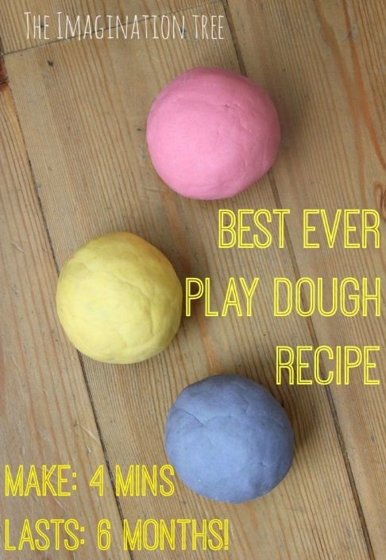
You need:
- 2 cups plain flour (all purpose)
- 2 tablespoons vegetable oil (baby oil and coconut oil work too)
- 1/2 cup salt
- 2 tablespoons cream of tartar
- 1 to 1.5 cups boiling water (adding in increments until it feels just right)
- gel food colouring (optional)
- few drops glycerine (my secret ingredient for stretch and shine!)

Method:
- Mix the flour, salt, cream of tartar and oil in a large mixing bowl
- Add food colouring TO the boiling water then into the dry ingredients
- Stir continuously until it becomes a sticky, combined dough
- Add the glycerine (optional)
- Allow it to cool down then take it out of the bowl and knead it vigorously for a couple of minutes until all of the stickiness has gone. * This is the most important part of the process, so keep at it until it’s the perfect consistency!*
- If it remains a little sticky then add a touch more flour until just right

