Year 6 Poetry!
Hi everyone, we are going to be spending a few days doing some work on poetry. Before we look at the poem I want you to do lesson 1. I hope you enjoy it!
Lesson 1 - Prediction | Look at these pictures and make a prediction about what you think the poem will be about.  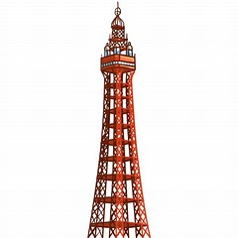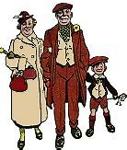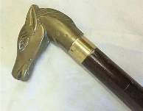  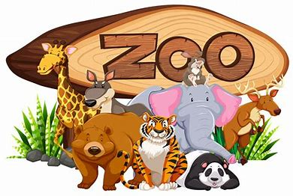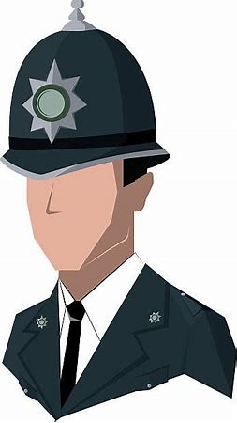
Lesson 2 | Listen to ‘The Lion and Albert’ performed by Stanley Holloway on YouTube (here). Or you can read the poem at the bottom of this page.  Organise a grid like this and record down what you like about the poem, what you dislike, what patterns you notice and what puzzles you.  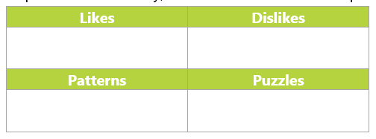
Lesson 3 | Copy these statements out. Think about the poem from yesterday. Colour code the statements. Red = I disagree, yellow = I’m not sure, Green = I agree.  This poem:  - engages my interest  - makes me cry  - makes me laugh  - makes me think  - makes me smile  - makes me shudder  - makes me gasp  - makes me angry  - fascinates me.  - Scares me
Lesson 4 | There are lots of examples in the poem of what we call ‘non-standard English’ can you find some examples and write down how it would be said using ‘standard English’.  ‘orse’s = Horse’s  ‘ead = Head  ‘andle = Handle  Fiddlin’ =  ‘im =  ‘ole =
Lesson 5 | There are some new words in this poem. I want you to create a table like the one below. Finish off my examples and then find some more unfamiliar words from the poem yourself and add to the table.  Unfamiliar word from poem Dictionary definition Sentence of my own  Noted Well known, famous The school was noted for its excellent teachers  Grand Marvellous, splendid The grand castle overlooked the mountainside.  Ale beer He finished his mug of ale and left the inn.
Lesson 6 | Look at the poem and see if you can be a poem detective finding clues that show where the poem was set, when it was set and anything that you find funny!  Where was it set? When was it set? What made you laugh?  The ocean was mentioned so it must be set near the sea. Used the word ‘ale’ which isn’t used anymore as we say ‘beer’. They say’drownded’ rather than ‘drowned’ and were a bit sad that they couldn’t see any ship wrecks.
Lesson 7 | Now that you have done a lot of work on the poem I would like you to do a piece of writing based on it. You can choose from the list below.  - A newspaper report about how a young boy was eaten at the zoo.  - A diary entry of one of the character’s in the story.  - A letter of complaint to the zoo from Mr and Mrs Ramsbottom  - An accident report filled in by the zookeeper stating what had happened.  - A cartoon strip of the poem.
Lesson 8 | Can you imagine that you have just witnessed everything that happened at the zoo. As the Ramsbottoms left without their son you stayed behind and saw what came next. Imagine that you are phoning a friend to let them know what you saw.  Write down your conversation with your friend.
Lesson 9 | Now read the next poem (Albert’s Return) which follows on from The Lion and Albert. You will find it here below.  Which was your favourite poem and why?  I preferred ……………………….. because……………………………….
The poems | The Lion and Albert  by Marriott Edgar  There's a famous seaside place called Blackpool,  That's noted for fresh air and fun,  And Mr and Mrs Ramsbottom  Went there with young Albert, their son.  A grand little lad was young Albert  All dressed in his best; quite a swell  With a stick with an 'orse's 'ead 'andle  The finest that Woolworth's could sell.  They didn't think much to the Ocean  The waves, they were fiddlin' and small  There was no wrecks and nobody drownded  Fact, nothing to laugh at, at all.  So, seeking for further amusement  They paid and went into the zoo  Where they'd lions and tigers and camels  And old ale and sandwiches too.  There were one great big lion called Wallace  His nose were all covered with scars  He lay in a somnolent posture  With the side of his face on the bars.  Now Albert had heard about lions  How they was ferocious and wild  To see Wallace lying so peaceful  Well, it didn't seem right to the child.  So straight 'way the brave little feller  Not showing a morsel of fear  Took his stick with its 'orse's 'ead 'andle  And shoved it in Wallace's ear.  You could see the lion didn't like it  For giving a kind of a roll  He pulled Albert inside the cage with 'im  And swallowed the little lad 'ole  Then Pa, who had seen the occurrence  And didn't know what to do next  Said 'Mother! Yon lions 'et Albert'  And Mother said 'Well, I am vexed!'  Then Mr and Mrs Ramsbottom  Quite rightly, when all's said and done  Complained to the Animal Keeper  That the lion had eaten their son.  The keeper was quite nice about it  He said, 'What a nasty mishap  Are you sure it's your boy he's eaten?'  Pa said, 'Am I sure? There's his cap!'  The manager had to be sent for  He came and he said 'What's to do?'  Pa said 'Yon lion's 'et Albert  And 'im in his Sunday clothes, too.'  Then Mother said, 'Right's right, young feller  I think it's a shame and a sin  For a lion to go and eat Albert  And after we've paid to come in.'  The manager wanted no trouble  He took out his purse right away  Saying, 'How much to settle the matter?'  And Pa said, 'What do you usually pay?'  But Mother had turned a bit awkward  When she thought where her Albert had gone  She said, 'No! someone's got to be summonsed!'  So that was decided upon.  Then off they went to the Police Station  In front of the Magistrate chap  They told 'im what happened to Albert  And proved it by showing his cap.  The Magistrate gave his opinion  That no one was really to blame  And he said that he hoped the Ramsbottoms  Would have further sons to their name.  At that Mother got proper blazing  'And thank you, sir, kindly,' said she  'What waste all our lives raising children  To feed ruddy lions? Not me!'  Albert’s Return  You've 'eard 'ow young Albert Ramsbottom  At the zoo up at Blackpool one year  With a stick with an 'orse's 'ead 'andle  Gave a lion a poke in the ear?  The name of the lion was Wallace,  The poke in the ear made 'im wild  And before you could say, "Bob's yer uncle!"  E'd upped and 'e'd swallowed the child.  'E were sorry the moment 'e done it;  With children 'e'd always been chums,  And besides, 'e'd no teeth in his muzzle,  And 'e couldn't chew Albert on't gums.  'E could feel the lad movin' inside 'im  As 'e lay on 'is bed of dried ferns;  And it might 'ave been little lad's birthday-  'E wished 'im such 'appy returns.  But Albert kept kickin' and fightin'...  And Wallace got up, feelin' bad.  Decided 'twere time that 'e started  To stage a comeback for the lad.  Then puttin' 'ead down in one corner,  On 'is front paws 'e started to walk;  And 'e coughed, and 'e sneezed, and 'e gargled  'Till Albert shot out... like a cork!  Now Wallace felt better directly  And 'is figure once more became lean.  But the only difference with Albert  Was 'is face and 'is 'ands were quite clean.  Meanwhile Mr. and Mrs. Ramsbottom  'Ad gone back to their tea, feelin' blue.  Ma said, "I feel down in the mouth, like.  " Pa said, "Aye, I bet Albert does, too."  Said Mother, "It just goes to show yer  That the future is never revealed;  If I'd thowt we was goin' to lose 'im,  I'd 'ave not 'ad 'is boots soled and 'eeled."  "Let's look on the bright side," said Father,  "Wot can't be 'elped must be endured;  Each cloud 'as a silvery lining,  And we did 'ave young Albert insured."  A knock on the door came that moment  As Father these kind words did speak.  'Twas the man from Prudential - 'e'd come for  Their tuppence per person per week.  When Father saw 'oo 'ad been knockin',  'E laughed, and 'e kept laughin' so -  The man said, "'Ere, wot's there to laugh at?"  Pa said, "You'll laugh an' all when you know!"  "Excuse 'im for laughing," said Mother,  "But really, things 'appen so strange  Our Albert's been et by a lion;  You've got to pay us for a change!"  Said the young man from the Prudential,  "Now, come, come, let's understand this...  You don't mean to say that you've lost 'im?"  Pa said, "Oh, no, we know where 'e is!"  When the young man 'ad 'eard all the details,  A purse from 'is pocket he drew  And 'e paid them with interest and bonus  The sum of nine pounds, four and two.  Pa 'ad scarce got 'is 'and on the money  When a face at the window they see  And Mother cried, "Eee, look, it's Albert!"  And Father said, "Aye, it would be."  Albert came in all excited,  And started 'is story to give;  And Pa said, "I'll never trust lions  Again, not as long as I live."  The young man from the Prudential  To pick up the money began  But Father said, "'ere, wait a moment,  Don't be in a 'urry, young man."  Then giving young Albert a shilling,  'E said, "'Ere, pop off back to the zoo;  Get your stick with the 'orse's 'ead 'andle...  Go and see wot the tigers can do!"

