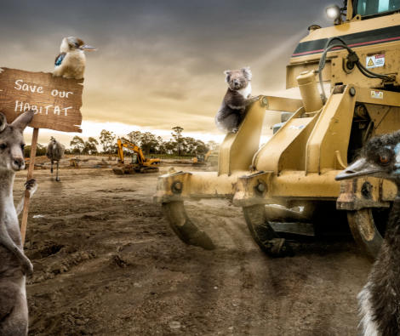

Story starter!
“Leave us alone! This is our home!” the animals all declared as one.
The humans didn’t seem to care…
Can you continue the story?
Or, can you persuade the humans to leave the animals alone? This could be a persuasive poster, leaflet or even a letter.

Make sure your writing contains:
MR INGLEBY’S GROUP | MR ATHERTON’S GROUP | MR WHALLEY’S GROUP
A range of different sentence openers,  A wide range of vocabulary – use https://www.wordhippo.com/ to explore synonyms.  Different punctuation – can you include an exclamation, command or question? | Include appropriate relative clauses to add further detail into your sentences.  Write in clear, concise paragraphs.  Check your completed writing to ensure capital letters and full stops have been used correctly. | Capital letters for the start of sentences and proper nouns.  A variety of sentence openers (_ly, _ed and _ing).  Appropriate and precise vocabulary (use https://www.wordhippo.com/ to explore synonyms).  Noun phrases  Check your work (capital letters and full stops, spellings and read every sentence to check for missing words).

If you want to, you could….
Draw a picture that shows:
1) The animals’ home before the diggers came along, and
2) What the scene looks like after the humans have finished on the site.

